**CT-303 Digital Communications**

**Name :** Dhrumil Mevada **ID** : 201901128

**Lab # 1 :** **Opamp as an Adder and Pulse Amplitude Modulation**

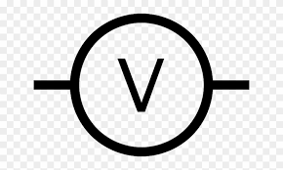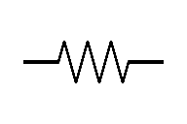**1)** In first part, we make a circuit which uses an Op-amp to add two different signals.

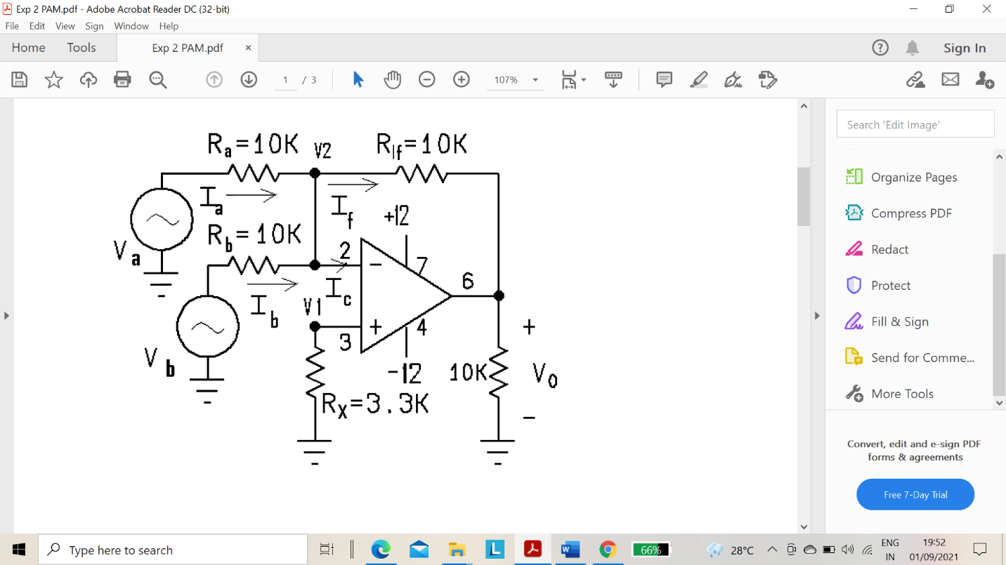

Rx = 3.3 k

-12v

+12v

Ro = 10 k

Vb

Va

R if= 10 k

Ra = 10 k

Rb = 10 k



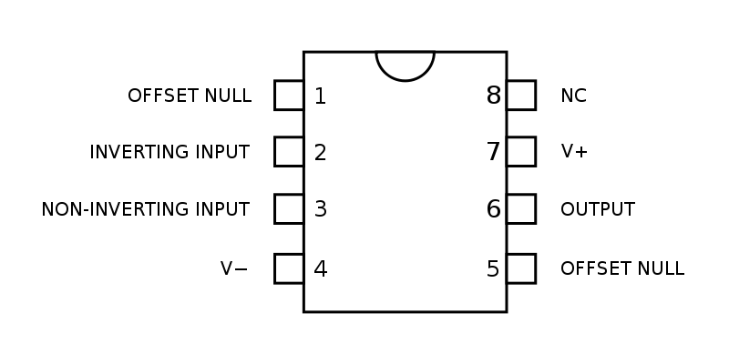









Vo

**Description:**

An adder circuit has two or more signal inputs either AC or DC and a single output.

The magnitude & polarity of the output at any given time is the algebraic sum of various inputs.

Depending on the relationship between feedback resistor Rf and the input resistors Ra & Rb the circuit can be used as a summing amplifier, a scaling amplifier or averaging amplifier.

At node v2 if we apply KCL then,

Ia + Ib = Ic + If

But here we use ideal Opamp so Ic = 0(Because in Opamp there will no current flow inside it) and V1 and V2 both are zero.

Therefore, Va/Ra + Vb/Rb = -Vo/Rf

And if we take Ra = Rb = Rf same we take then

**Vo = - (Va + Vb)**

* **Therefore circuit works as summing amplifier & output voltage is equal to negative sum of all input voltages**

**2)** **Pulse Amplitude Modulation (PAM):** Pulse-amplitude modulation is a form of signal modulation where the message information is encoded in the amplitude of a series of signal pulses.

It is an analog pulse modulation scheme in which the amplitudes of a train of carrier pulses are varied according to the sample value of the message signal



In this experiment, we will use a single frequency sine

wave to test the circuit. 

* 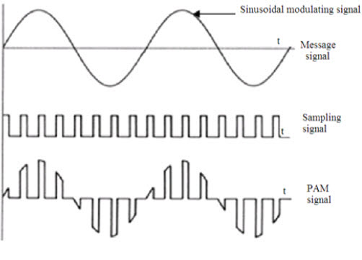So output from PAM look like as follow:
* When we increase the frequency of carrier signal the amplitude did not affect (Because just we multiply amplitude of carrier signal and message signal) but pulses in PAM signal come closer to each other so that we can say the frequency of output signal also increases means that sample of input/message signal is increase and vice versa for decreasing frequency.

**Q :- Count the number of pulses in one period for carrier frequency.**

* Suppose Message signal frequency = 500 Hz.

1. **For Carrier frequency = 1KHz.**

fm = 500Hz => Tm = 2 ms.

fc = 1000Hz => 1000 pulses in 1 sec

so it will be 1000 * 2 * 10E-3 = 2 pulses for Time period

1. **For Carrier frequency = 1.5KHz.**

fm = 500Hz => Tm = 2 ms.

fc = 1500Hz => 1500 pulses in 1 sec

so it will be 1500 * 2 * 10E-3 = 3 pulses for Time period

1. **For Carrier frequency = 2KHz.**

fm = 500Hz => Tm = 2 ms.

fc = 2000Hz => 2000 pulses in 1 sec

so it will be 2000 * 2 * 10E-3 = 4 pulses for Time period

* 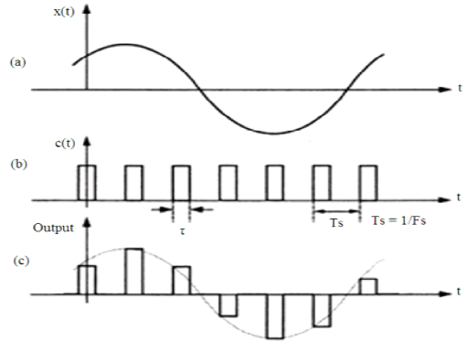PFM application is that it is a method of encoding analog signals into trains of square pulses and therefore has a wide variety of applications.

**LAB** **#2:- Pulse Width Modulation and Pulse Position Modulation and**

**Generating the PPM Wave using PWM Wave.**

**AIM :-** **To study Pulse Width Modulation and Pulse Position**

**Modulation and generating the PPM wave by using PWM wave.**

**PULSE-WIDTH MODULATION (PWM):-**

Pulse-width modulation (PWM) of a signal involves the modulation of its duty cycle, to convey information over a communications channel. PWM uses a square wave whose duty cycle is modulated resulting in the variation of the average value of the waveform.

PWM has pulses having different widths(different TON). Pulse width is depended on duty cycle.

* **Duty cycle = (TON + TOFF)/T .**
* **If TON=TOFF then we get a square wave with 50% duty cycle.**

In Present lab we are using 555 timer circuit to generate PWM wave. The timer output waveform may be changed by modulating the control voltage applied to the timer's pin 5 by changing the reference of the timer's internal comparators. When the continuous trigger pulse train is applied in the mono stable mode, the timer output width is modulated according to the signal applied to the control terminal.

**PULSE POSITION MODULATION (PPM) :-**

The amplitude and width of the pulse is kept constant in the system. The position of each pulse, in relation to the position of a recurrent reference pulse, is varied by each instantaneous sampled value of the modulating wave.

In PPM TON and TOFF of each pulse are same but the pulse can be positioned anyway.

In this lab we are using PWM wave as triggering input to another 555 timer to generate PPM wave.

* **555 TIMER INTERNAL DIAGRAM :**

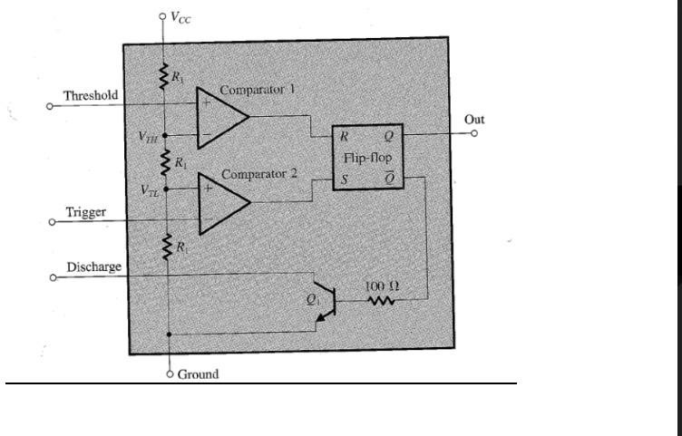

* **CIRCUIT FOR GENERATING PWM AND PPM :**

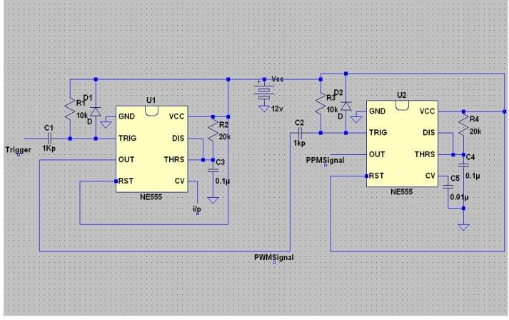

**PROCEDURE:-**

* Connect the Circuit as Shown in the figure and initially don’t apply any modulating signal.
* Apply Square Wave of 8Vp-p and frequency of 2 KHz as Triggering input. Note the values of capacitor charging period at PIN 6 and voltage at PIN 5 for both 555 timers.
* For first 555 timer time period should satisfy the criteria T=1.1RC as 555 operating in mono stable mode.
* Now Apply D.C off set of 8V from function Generator as modulating signal at PIN 5 and observe PWM, PPM waves. Now vary the D.C offset; observe the results and plot diagrams..
* Now Apply sine wave of voltage 2Vp-p and frequency of 500Hz along with D.C offset of 8V from Function Generator.
* Adjust the Amplitudes and frequencies of Modulating Signal and Triggering Signal until you obtain clear PWM and PPM waves.

**WORKING :-**

* When IC555 is reset, the output voltage = 0 V. since voltage is low, transistor is in ON condition and thus capacitors will charge. As capacitor voltage reaches 1/3(VCC) we get high output until capacitor voltage reaches 2/3(VCC).
* At high output capacitor slowly starts to discharge and after 2/3(VCC) is crossed we get low output. Thus the width of output pulse is dependent on charging and discharging of capacitors. Hence we get different width in output PWM signal.

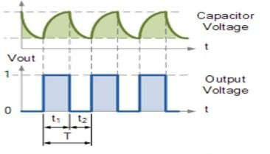

* When we fed this PWM signal to a mono stable multi vibrator, we get a pulse width at output wherever there is a high to low transition at different time-period.
* Hence we get a PPM signal having different positions.